# Lab: HTTP BASICS

Problems for in-class lab for the [“Technology Fundamentals” course @ SoftUni](https://softuni.bg/trainings/2056/technology-fundamental-september-2018#lesson-9616).

# Installing needed Software

## Postman

You can download Postman from [here](https://www.getpostman.com/apps).

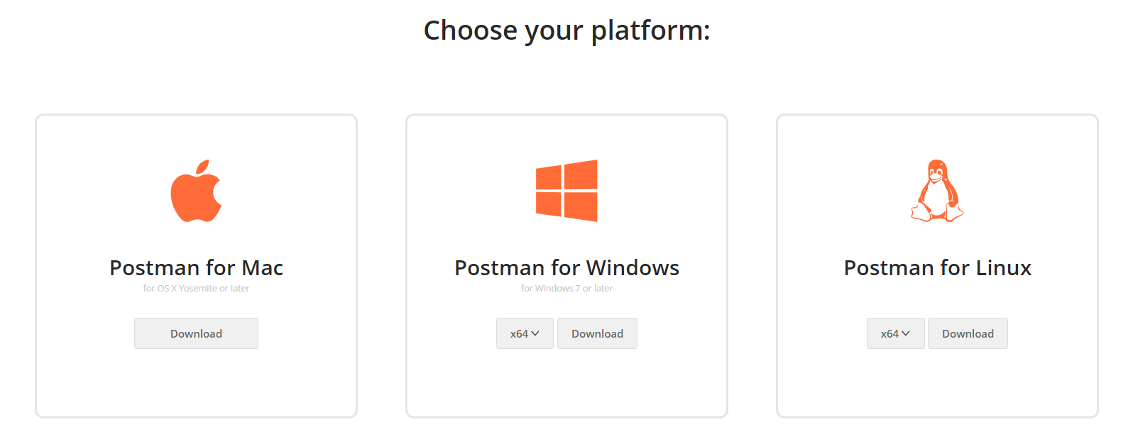

# Make basic HTTP requests

## HTTP GET request

Using Postman make a simple **GET** request. Try to **GET** your favorite web site.

**Paste** link in the input box, then click "**Send**".

**Check** the response.

## GitHub repos for Organization "SoftUni-Tech-Module"

First you have to list all user’s public repositories. can do it with simple **GET** request.

**Request to:** [https://api.github.com/users/SoftUni-Tech-Module/repos](https://api.github.com/users/Tech-Module-Jan-2018/repos)

**Response:**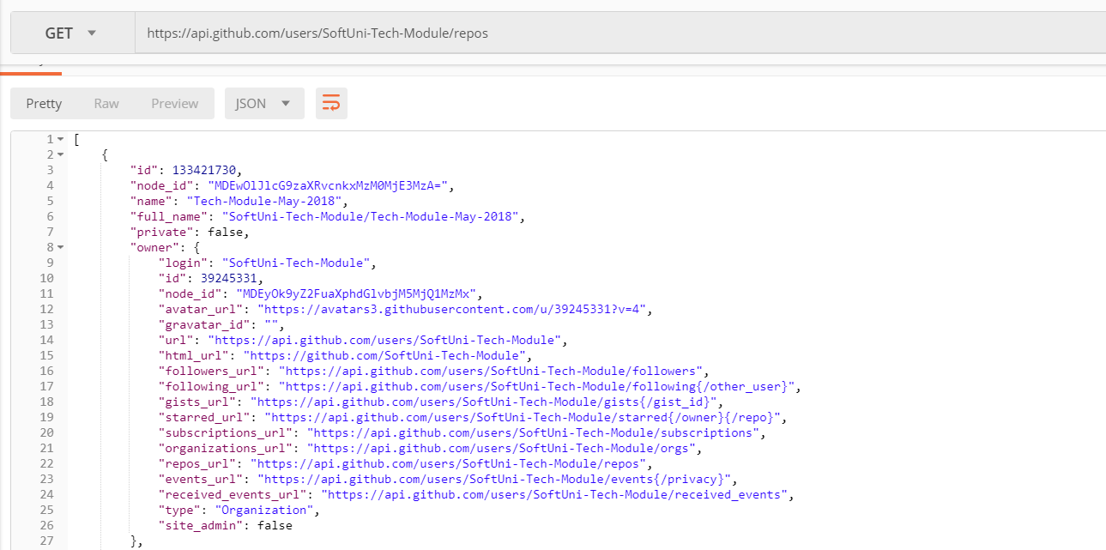

## GET issue from (SoftUniTechModule/TestRepository)

Now get the first issue from "TestRepository". Send a **GET** request to https://api.github.com/repos/SoftUni-Tech-Module/TestRepository/issues/id, where "**id**" is the index of issue. Try with **1.**

## Create Issue

This time we will **create** an issue and **send** it to the server.

You need to use your GitHub **account credentials** to send the request. Under the **Authorization** tab, select "**Basic** **Auth**" and enter your username and password.

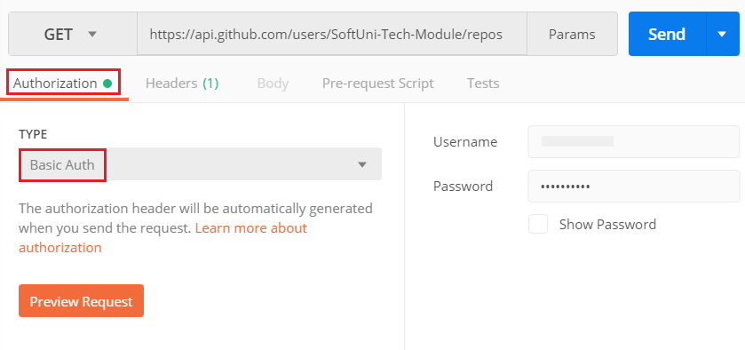

Then send a **POST** request to the server with the following JSON as **body**.

